the following reports are included with JIRA:

* [Average Age Report](https://confluence.atlassian.com/display/JIRA062/Average+Age+Report) — Shows the average age (in days) of unresolved issues.
* [Created vs Resolved Issues Report](https://confluence.atlassian.com/display/JIRA062/Created+vs+Resolved+Issues+Report) — Shows the number of issues created vs number of issues resolved over a given period of time.
* [Pie Chart Report](https://confluence.atlassian.com/display/JIRA062/Pie+Chart+Report) — Shows the search results from a specified [issue filter](https://confluence.atlassian.com/display/JIRA062/Using+Filters) (or [project](https://confluence.atlassian.com/display/JIRA062/What+is+a+Project)) in a pie-chart, based on a statistic of your choice.
* [Resolution Time Report](https://confluence.atlassian.com/display/JIRA062/Resolution+Time+Report) — Shows the average time taken to resolve issues.
* [Recently Created Issues Report](https://confluence.atlassian.com/display/JIRA062/Recently+Created+Issues+Report) — Shows the rate at which issues are being created.
* [Single Level Group By Report](https://confluence.atlassian.com/display/JIRA062/Single+Level+Group+By+Report) — Shows the search results from an [issue filter](https://confluence.atlassian.com/display/JIRA062/Using+Filters), grouped by a field of your choice.
* [Time Since Issues Report](https://confluence.atlassian.com/display/JIRA062/Resolution+Time+Report) — Shows the number of issues for which your chosen date field (e.g. 'Created') was set on a given date.
* [Time Tracking Report](https://confluence.atlassian.com/display/JIRA062/Time+Tracking+Report) – Shows [time tracking information](https://confluence.atlassian.com/display/JIRA/Logging+Work+on+an+Issue) on issues for a particular [version](https://confluence.atlassian.com/display/JIRA/What+is+a+Project#WhatisaProject-versions) of a project.
* [User Workload Report](https://confluence.atlassian.com/display/JIRA062/User+Workload+Report) * — Shows how much work a user has been allocated, and how long it should take.
* [Version Time Tracking Report](https://confluence.atlassian.com/display/JIRA062/Time+Tracking+Report) * — Shows progress towards completing a given version, based on issues' work logs and time estimates.
* [Version Workload Report](https://confluence.atlassian.com/display/JIRA062/Version+Workload+Report) * — Shows how much outstanding work there is (per user and per issue) before a given version is complete.
* [Workload Pie Chart Report](https://confluence.atlassian.com/display/JIRA062/Workload+Pie+Chart+Report) * — Shows the relative workload for assignees of all issues in a particular [project](https://confluence.atlassian.com/display/JIRA062/What+is+a+Project) or [issue filter](https://confluence.atlassian.com/display/JIRA062/Using+Filters).

The project browser screen allows you to browse a [project](https://confluence.atlassian.com/display/JIRA062/What+is+a+Project) or its [components](https://confluence.atlassian.com/display/JIRA062/What+is+a+Project#WhatisaProject-components) or [versions](https://confluence.atlassian.com/display/JIRA062/What+is+a+Project#WhatisaProject-versions), the latter of which shows you summaries of your project's progress.

This screen provides a general overview of your project, with a variety of easily accessible reports for your project's issues, builds and source code reviews, from which you can 'dig down' into further detail.

From the project browser screen, you can browse the following:

* **Project:**
  + [Summary](https://confluence.atlassian.com/display/JIRA062/Browsing+a+Project%27s+Summary) — Shows recent activity in your project, unreleased versions and a chart showing issue activity. Reports are also located here.
  + [Issues](https://confluence.atlassian.com/display/JIRA062/Browsing+a+Project%27s+Issues) — Shows a summary of all issues in a project grouped by Status. Also shows summaries of all unresolved issues, grouped by Assignee, Priority, Version and Component.
  + [Road Map](https://confluence.atlassian.com/display/JIRA062/Browsing+a+Project%27s+Road+Map) — Shows unresolved issues for upcoming versions of a project.
  + [Change Log](https://confluence.atlassian.com/display/JIRA062/Browsing+a+Project%27s+Change+Log) — Shows resolved issues for previous versions of a project.
  + [Versions](https://confluence.atlassian.com/display/JIRA062/Browsing+a+Project%27s+Versions) * — Shows a summary of recent versions for a given project.
  + [Components](https://confluence.atlassian.com/display/JIRA062/Browsing+a+Project%27s+Components) * — Shows a summary of all components for a given project.
  + [Builds](https://confluence.atlassian.com/display/JIRA062/Browsing+a+Project%27s+Bamboo+Builds) * — Shows recent Bamboo builds for a given project.
  + [Reports](https://confluence.atlassian.com/display/JIRA062/Generating+Reports) – Shows reports on statistics for particular people, projects, versions, or other fields within issues.
* **Version:**
  + [Version Summary](https://confluence.atlassian.com/display/JIRA062/Browsing+a+Version%27s+Summary) — Shows recent activity in a given version of a project, plus a list of issues that are due soon.
  + [Version Issues](https://confluence.atlassian.com/display/JIRA062/Browsing+a+Version%27s+Issues) — Shows issues belonging to a given version of a project.
  + [Version Popular Issues](https://confluence.atlassian.com/display/JIRA062/Browsing+a+Version%27s+Popular+Issues) — Shows unresolved issues for a given version, ordered by popularity (votes).
  + [Version Builds](https://confluence.atlassian.com/display/JIRA062/Browsing+a+Version%27s+Bamboo+Builds) * — Shows recent Bamboo builds for a given version.
* **Component:**
  + [Component Summary](https://confluence.atlassian.com/display/JIRA062/Browsing+a+Component%27s+Summary) — Shows recent activity in a given component of a project, plus a list of issues that are due soon.
  + [Component Issues](https://confluence.atlassian.com/display/JIRA062/Browsing+a+Component%27s+Issues) — Shows issues belonging to a given component of a project.
  + [Component Road Map](https://confluence.atlassian.com/display/JIRA062/Browsing+a+Component%27s+Road+Map) — Shows unresolved issues for a given component, for upcoming versions of the project.
  + [Component Change Log](https://confluence.atlassian.com/display/JIRA062/Browsing+a+Component%27s+Change+Log) — Shows resolved issues for a given component, for previous versions of the project.
  + [Component Popular Issues](https://confluence.atlassian.com/display/JIRA062/Browsing+a+Component%27s+Popular+Issues) — Shows unresolved issues for a given component, ordered by popularity (votes).

* *Only available if your organization uses* [*Atlassian Bamboo*](http://www.atlassian.com/software/bamboo). *Your administrator must also* [*integrate Bamboo with JIRA*](http://confluence.atlassian.com/display/BAMBOO/Integrating+Bamboo+with+JIRA).

To create your own dashboard:

1. At the top right of the Dashboard, click the '**Tools**' menu.
2. Select either '**Create Dashboard**' to create a blank dashboard, or '**Copy Dashboard**' to create a copy of the dashboard you are currently viewing.

Choosing a Dashboard Layout

To choose a different layout for your dashboard page (e.g. three columns instead of two):

1. At the top right of the Dashboard, click the '**Edit Layout**' link. A selection of layouts will be displayed:  
   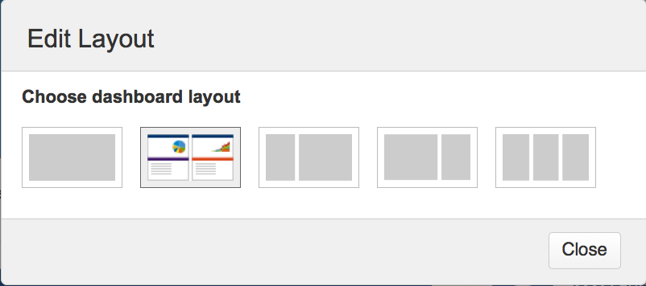
2. Click your preferred layout.

Adding a Gadget

1. At the top right of the Dashboard, click the '**Add Gadget**' link.
2. A selection of gadgets will be displayed:  
   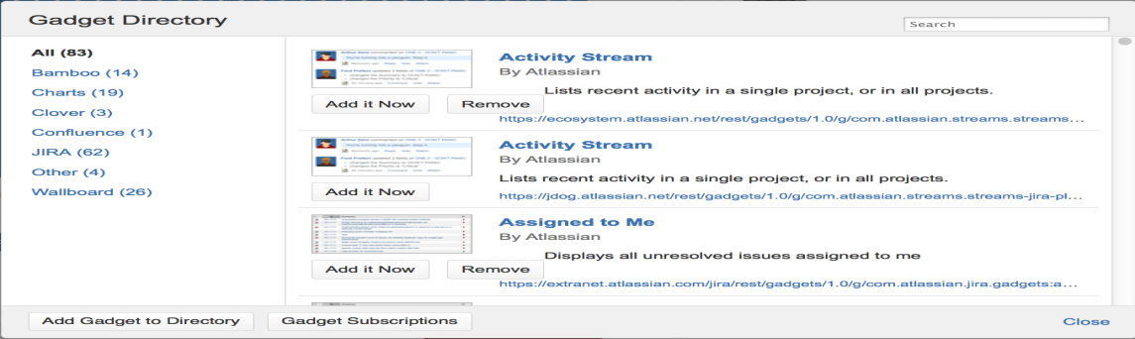  
     
   (tick)Select a category on the left to restrict the list of gadgets on the right to that category.
3. Click the '**Add it now**' button beneath your chosen gadget.
4. Click the '**Finished**' button to return to your Dashboard.
5. If the gadget you have selected requires configuration, you will be presented with the gadget's configuration page. Configure appropriately and click '**Save**'.

Moving a Gadget

To move a gadget to a different position on your dashboard:

* Click the gadget and drag it into its new position
* Removing a Gadget

To remove a gadget from your dashboard:

1. Hold your mouse over the top right corner of the gadget, until a down-arrow appears.
2. Click the down-arrow to display the following menu:  
   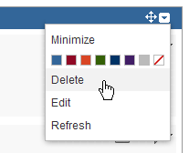
3. Click '**Delete**'.

Using the Summary tab

The **Summary** tab page shows your personal details registered in JIRA, your personal JIRA preferences, the number of open issues assigned to you by project and a list of your recent activity.

Details

In the **Details** section on the **Summary** tab page, you can do the following:

* Click the **edit** icon https://confluence.atlassian.com/download/attachments/588581672/edit-icon.png?version=1&modificationDate=1355273680543&api=v2at the top-right of the section to open the **Edit Profile** dialog box. From here, you can edit the following details:
  + **Full Name** – your display-name – that is, the name by which you are known in JIRA.
  + **Email** – the email address to which your JIRA notifications will be sent.
  + **Password** – you are required to enter your password to save changes to your **Full Name** and **Email** address.
  + Click the **Update** button to save your changes.
* Click the **Avatar** icon https://confluence.atlassian.com/download/attachments/588581672/add-avatar.png?version=1&modificationDate=1355273686161&api=v2 to [add an avatar](https://confluence.atlassian.com/display/JIRA062/Adding+a+User+Avatar) to your user profile.  
  (info)If you have already added a user avatar to your JIRA profile, that (current) avatar will appear instead of icon above. Clicking your current avatar allows you to change it.
* Click the **Administer User** link to view or edit your [user details](https://confluence.atlassian.com/display/JIRA062/Managing+Users) in JIRA's administration area.  
  (info)This option is only available to if you are a [**JIRA Administrator**](https://confluence.atlassian.com/display/JIRA062/Managing+Global+Permissions).
* Click the **email address** to send an email to that address via your registered email client application.
* Click the **Change Password** link to [change your JIRA password](https://confluence.atlassian.com/display/JIRA062/Changing+your+Password).
* Click the **Clear All Tokens** link to clear your 'Remember my login' tokens. This feature is useful if you have accessed JIRA in a public environment, selected the **Remember by login...** check box before logging in, but you may have forgotten to log out and do not wish others to access JIRA through your account. See [Clearing 'Remember my login' Tokens](https://confluence.atlassian.com/display/JIRA062/Clearing+%27Remember+my+login%27+Tokens) for more information.
* Click the **View Project Roles** link to view or edit that [user's project roles](https://confluence.atlassian.com/display/JIRA062/Managing+Users#ManagingUsers-projectroles) in JIRA's administration area.  
  (info)This option is only available to users who are [**JIRA Administrators**](https://confluence.atlassian.com/display/JIRA062/Managing+Global+Permissions).

Note

Icon

If your JIRA administrator has configured the user directory containing your account with external password management, the **Edit Profile** and **Change Password** links may not be available.

Preferences

In the **Preferences** section on the **Summary** tab page, you can do the following:

* Click the **edit** icon https://confluence.atlassian.com/download/attachments/588581672/edit-icon.png?version=1&modificationDate=1355273680543&api=v2at the top-right of the section to open the **Updated User Preferences** dialog box:  
  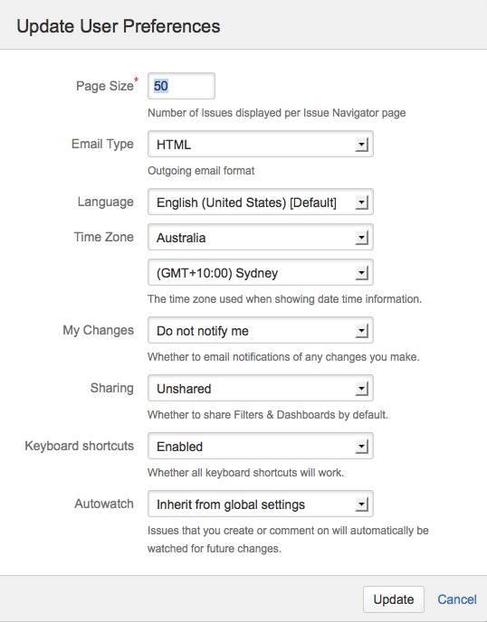
* From here, you can edit the following details:  
  + **Page Size** – The number of issues displayed on each Issue Navigator page. This field is mandatory and the default value is 50.
  + **Email Type** – The format (text or HTML) in which JIRA sends its outgoing email notifications.
  + **Language** – Your preferred [language](https://confluence.atlassian.com/display/JIRA062/Choosing+a+Language).
  + **Time Zone** – Your preferred [time zone](https://confluence.atlassian.com/display/JIRA062/Choosing+a+Time+Zone).
  + **My Changes** – Choose between making JIRA send you email notifications about issue updates made by either both you and other people (**Notify me**) or other people only (i.e. **Do not notify me**).
  + **Filter & Dashboard Sharing / Sharing (in dialog box)** – Choose the default 'sharing' setting for when you create new filters and dashboards, which can be either shared with all other users (**Public**) or restricted  
    to your viewing only (**Private**).
  + **Keyboard Shortcuts** – Choose between making JIRA's [Keyboard Shortcuts feature](https://confluence.atlassian.com/display/JIRA062/Using+Keyboard+Shortcuts) either **Enabled** or **Disabled**.
  + **Autowatch** – Choose between allowing JIRA to automatically make you a [watcher](https://confluence.atlassian.com/display/JIRA062/Watching+and+Voting+on+an+Issue) of any issues that you create or comment on.
* Click **View Navigator Columns** to choose which fields appear in your [Issue Navigator](https://confluence.atlassian.com/display/JIRA062/Customizing+your+Issue+Navigator#CustomizingyourIssueNavigator-configuringnavigatorcolumns).

(tick)**Tip:** The global defaults for most of the user preferences above can be set by your JIRA administrator (**Administration > User Preferences**). Your preferences will override the global preferences, but if you haven't explicitly changed any settings they will be inherited from the global settings.

Assigned Open Issues per Project

In the **Assigned Open Issues per project** section on the **Summary** tab page, you can do the following:

* Click the name of the project (on the left) to [browse that project's roadmap](https://confluence.atlassian.com/display/JIRA062/Browsing+a+Project%27s+Road+Map).
* Click the number of open issues (on the right) to [display the Issue Navigator](https://confluence.atlassian.com/display/JIRA062/Using+the+Issue+Navigator), which shows your list of open issues associated with the project on the left.

Activity Stream

In the **Activity Stream** on the right of the **Summary** tab page, you can:

* Click any item to jump to an issue or other activity in which you have recently participated. Your Activity Stream can include:
  + Issues in your local JIRA system.
  + Issues in another JIRA system, provided your administrator has configured a [two-way Application Link](https://confluence.atlassian.com/display/JIRA062/Adding+an+Application+Link) ().
  + Activity from another Atlassian application, such as:  
    - document updates (from Confluence)
    - code commits (from FishEye)
    - code reviews (from Crucible)
    - builds (from Bamboo)  
      (info)Note that this requires your administrator to configure a [two-way Application Link](https://confluence.atlassian.com/display/JIRA062/Adding+an+Application+Link), unless you are using Atlassian OnDemand.
  + Activity from remote applications. Your administrator will need to set this up via the [REST API](https://developer.atlassian.com/display/STREAMS/How+to+Add+Activities+to+a+Third+Party+Feed+%28REST+API%29) or the [provider plugin API](https://developer.atlassian.com/display/STREAMS/Making+your+own+Activity+Streams+Provider), or locally via [Java](https://developer.atlassian.com/display/STREAMS/How+to+Add+Activities+to+a+Third+Party+feed+%28Java+API%29) ().
* Click the RSS icon https://confluence.atlassian.com/download/attachments/588581617/rss_icon.png?version=1&modificationDate=1247538360585&api=v2to generate an RSS feed of information that is relevant to you.
* Click the cog drop-down to refresh the displayed Activity Stream.

(tick)The Activity Stream is also available as a [gadget](https://confluence.atlassian.com/display/JIRA062/Adding+the+Activity+Stream+Gadget).

Filters

Click the **Filters** menu at the top of the **Summary** tab page. From this menu you can:

* Click **Assigned** to list all issues that are assigned to you, irrespective of their current [status](https://confluence.atlassian.com/display/JIRA062/What+is+an+Issue#WhatisanIssue-Status).
* Click **Assigned & Open** to list the issues that are assigned to you and are unresolved.
* Click **Assigned & In Progress** to list the issues that are assigned to you and whose current status is **In Progress**.
* Click **Reported** to list the issues that were [created](https://confluence.atlassian.com/display/JIRA062/Creating+an+Issue) by you, irrespective of their current [status](https://confluence.atlassian.com/display/JIRA062/What+is+an+Issue#WhatisanIssue-Status).
* Click **Reported & Open** to list the issues that were [created](https://confluence.atlassian.com/display/JIRA062/Creating+an+Issue) by you and are unresolved.
* Click **Voted** to view the list of issues for which you have [voted](https://confluence.atlassian.com/display/JIRA062/Watching+and+Voting+on+an+Issue), irrespective of their current [status](https://confluence.atlassian.com/display/JIRA062/What+is+an+Issue#WhatisanIssue-Status).
* Click **Voted & Open** to view the list of issues for which you have [voted](https://confluence.atlassian.com/display/JIRA062/Watching+and+Voting+on+an+Issue) and are unresolved.
* Click **Watched** to view the list of issues that you are [watching](https://confluence.atlassian.com/display/JIRA062/Watching+and+Voting+on+an+Issue), irrespective of their current [status](https://confluence.atlassian.com/display/JIRA062/What+is+an+Issue#WhatisanIssue-Status).
* Click **Watched & Open** to view the list of issues that you are [watching](https://confluence.atlassian.com/display/JIRA062/Watching+and+Voting+on+an+Issue) and are unresolved.

Using the Roadmap tab

The **Roadmap** tab page shows your 'Personal Road Map' report, which provides quick access to work assigned to you across all projects.

On the **Roadmap** tab page, you can do the following:

* In the **Change Project** field, select a project to show a personal road map report for work assigned to you for that project. This is similar in functionality to [browsing a project's roadmap](https://confluence.atlassian.com/display/JIRA062/Browsing+a+Project%27s+Road+Map), although the personal road map shows only issues assigned to you.
* Click the **View global road map** link to show all work required for that project.

Using the Tools menu

Click the '**Tools**' menu in the top right to open it. From this menu you can click **View OAuth Access Tokens** to view and edit your [OAuth Tokens](https://confluence.atlassian.com/display/JIRA062/Allowing+OAuth+Access).

Issue Type

JIRA can be used to track many different types of issues. The default types are listed below, but please note that your JIRA administrator may have [customized](https://confluence.atlassian.com/display/JIRA062/Defining+Issue+Type+Field+Values) this list to suit your organization.

https://confluence.atlassian.com/download/attachments/588581688/bug.gif?version=1&modificationDate=1378712313824&api=v2**Bug** — A problem which impairs or prevents the functions of the product.  
https://confluence.atlassian.com/download/attachments/588581688/improvement.gif?version=1&modificationDate=1378712321926&api=v2**Improvement** — An enhancement to an existing feature.  
https://confluence.atlassian.com/download/attachments/588581688/newfeature.gif?version=1&modificationDate=1378712324137&api=v2**New Feature** — A new feature of the product.  
https://confluence.atlassian.com/download/attachments/588581688/task.gif?version=1&modificationDate=1378712326255&api=v2**Task** — A task that needs to be done.  
https://confluence.atlassian.com/download/attachments/588581688/genericissue.gif?version=1&modificationDate=1378712360128&api=v2**Custom Issue** — A custom issue type, as defined by your organization if required.

Priority

An issue's priority indicates its relative importance. The default priorities are listed below; note that both the priorities and their meanings can be [customized](https://confluence.atlassian.com/display/JIRA062/Defining+Priority+Field+Values) by your JIRA administrator to suit your organization.

https://confluence.atlassian.com/download/attachments/588581688/priority_blocker.gif?version=1&modificationDate=1378712335187&api=v2**Blocker** — Highest priority. Indicates that this issue takes precedence over all others.  
https://confluence.atlassian.com/download/attachments/588581688/priority_critical.gif?version=1&modificationDate=1378712337587&api=v2**Critical** — Indicates that this issue is causing a problem and requires urgent attention.  
https://confluence.atlassian.com/download/attachments/588581688/priority_major.gif?version=1&modificationDate=1378712339651&api=v2**Major** — Indicates that this issue has a significant impact.  
https://confluence.atlassian.com/download/attachments/588581688/priority_minor.gif?version=1&modificationDate=1378712331195&api=v2**Minor** — Indicates that this issue has a relatively minor impact.  
https://confluence.atlassian.com/download/attachments/588581688/priority_trivial.gif?version=1&modificationDate=1378712328623&api=v2**Trivial** — Lowest priority.

Status

Each issue has a status, which indicates where the issue currently is in its [lifecycle](https://confluence.atlassian.com/display/JIRA062/What+is+Workflow) ('workflow'). An issue starts as being 'Open', then generally progresses to 'Resolved' and then 'Closed'; or, depending on circumstances, it may progress to other statuses. Please also note that your JIRA administrator may have [customized](https://confluence.atlassian.com/display/JIRA062/Defining+Status+Field+Values) the available statuses to suit your organization.

https://confluence.atlassian.com/download/attachments/588581688/status_open.gif?version=1&modificationDate=1378712317344&api=v2**Open** — This issue is in the initial 'Open' state, ready for the assignee to start work on it.  
https://confluence.atlassian.com/download/attachments/588581688/status_inprogress.gif?version=1&modificationDate=1378712347005&api=v2**In Progress** — This issue is being actively worked on at the moment by the assignee.  
https://confluence.atlassian.com/download/attachments/588581688/status_resolved.gif?version=1&modificationDate=1378712319960&api=v2**Resolved** — A [Resolution](https://confluence.atlassian.com/display/JIRA062/What+is+an+Issue#WhatisanIssue-Resolution) has been identified or implemented, and this issue is awaiting verification by the reporter. From here, issues are either 'Reopened' or are 'Closed'.  
https://confluence.atlassian.com/download/attachments/588581688/status_reopened.gif?version=1&modificationDate=1378712341830&api=v2**Reopened** — This issue was once 'Resolved' or 'Closed', but is now being re-examined. (For example, an issue with a *Resolution* of 'Cannot Reproduce' is Reopened when more information becomes available and the issue becomes reproducible). From here, issues are either marked *In Progress,* *Resolved* or *Closed.*   
https://confluence.atlassian.com/download/attachments/588581688/status_closed.gif?version=1&modificationDate=1378712344217&api=v2**Closed** — This issue is complete.

Resolution

An issue can be resolved in many ways, only one of them being 'Fixed'. A resolution is usually set when the status is changed. The default resolutions are listed below; note that your JIRA administrator may have [customized](https://confluence.atlassian.com/display/JIRA062/Defining+Resolution+Field+Values) these to suit your organization.

**Fixed** — A fix for this issue has been implemented.  
**Won't Fix** — This issue will not be fixed, e.g. it may no longer be relevant.  
**Duplicate** — This issue is a duplicate of an existing issue. Note: it is recommended you create a [link](https://confluence.atlassian.com/display/JIRA062/Configuring+Issue+Linking) to the duplicated issue.  
**Incomplete** — There is not enough information to work on this issue.  
**Cannot Reproduce** — This issue could not be reproduced at this time, or not enough information was available to reproduce the issue. If more information becomes available, please reopen the issue.